Tbar

Chart_9 1m 06s
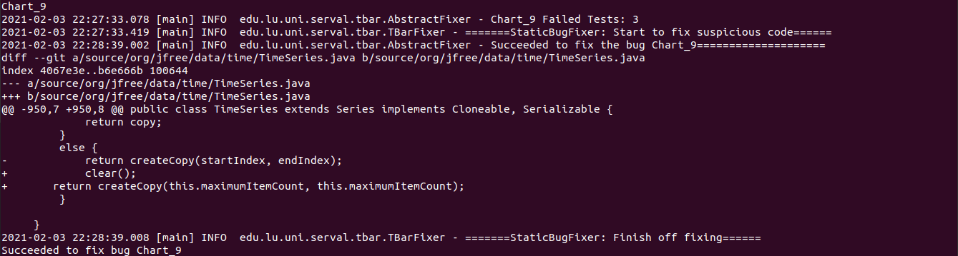

Chart_11 25m 39s
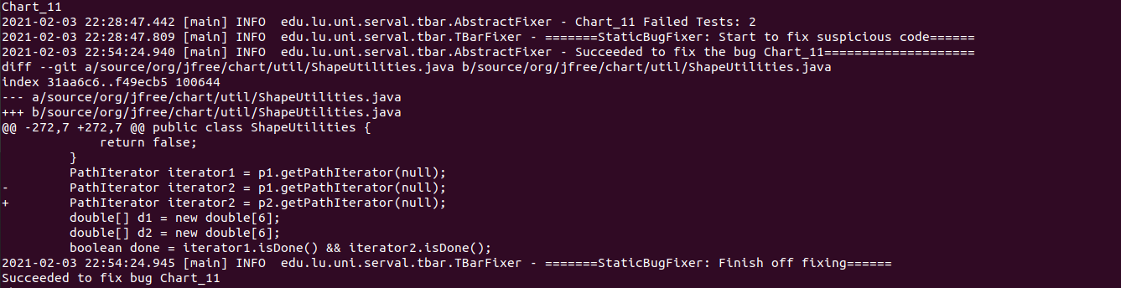
Chart_14 Time over(1h)

Chart_19 Time Over(1h)

